Scoil Náisiúnta an Chroí Ró-Naofa

Uimhir Rolla: 13741Q  Fón: 057-8626270  E-mail: office@rathns.com  principal@rathns.com  Web: www.rathns.ie | 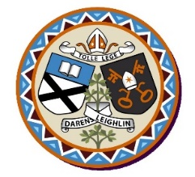  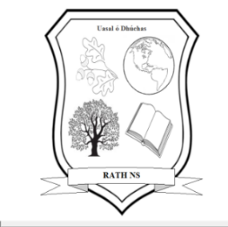 | An Ráth  Bailebriotás,  Portlaoise,  Co. Laois  R32Y510

Annual Admission Notice
in respect of admissions to the 2025-2026 school year
A copy of the school’s Admission Policy and the Application Form for Admission for the 2025/2026 school year is available as follows:
To download at: www.rathns.ie
On request: By emailing office@rathns.com or writing to above address

Part 1 - Admissions to the 2025/2026 school year
Application and Decision Dates for admission to Sacred Heart N.S., Rath

The following are the dates applicable for admission to Junior Infants:
The school will commence accepting applications for admission on | October 25th 2024
The school shall cease accepting applications for admission on | November 15th 2024
The date by which applicants will be notified of the decision on their application is | December 6th 2024
The period within which applicants must confirm acceptance of an offer of admission is | December 20th 2024

Special Class for Children with Autism Application and Decision Dates for admission to Sacred Heart N.S., Rath
The following are the dates applicable for admission to our special class for children with autism:
The school will commence accepting applications for admission on | October 25th 2024
The school shall cease accepting applications for admission on | November 15th 2024
The date by which applicants will be notified of the decision on their application is | December 6th 2024
The period within which applicants must confirm acceptance of an offer of admission is | December 20th 2024

Note: the school will consider and issue decisions on late applications in accordance with the school’s Admission Policy

*Failure to accept an offer within the prescribed period above may result in the offer being withdrawn

Number of Places being made Available in 2024-2026 School Year

The number of places being made available in Junior Infants | 25
The number of places being made available in the Special Class for children with autism | 4

Part 2 - Admissions to the 2024-2025 school year.
Information regarding the admission process for the Intake Group for our Special Class for the 2024-2025 school year

In respect of the 2024-2025 school year, the total number of applications for admission received for the special class for children with autism was 19.
Breakdown of places allocated for the 2024-2025 school year:
Number of places available: | 2
Number of applications received: | 19
Number of Offers made and accepted under each criteria:  Children presently enrolled in the school with a recommendation for a placement in a special class attached to a mainstream school. | A description of each criterion used and the number of places offered and accepted under that criterion must be entered here.  Two places offered.  Two places accepted.
Total number of offers made | 2
Number of names placed on waiting list for the school year concerned. | 17

