Scoil Náisiúnta an Chroí Ró-Naofa

Uimhir Rolla: 13741Q  Fón: 057-8626270  E-mail: office@rathns.com  principal@rathns.com  Web: www.rathns.ie | 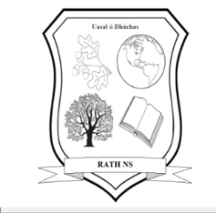 | An Ráth  Bailebriotás,  Portlaoise,  Co. Laois  R32Y510

Parents’ Association Smartphone Agreement

Agreement: My child will not own a smartphone or have access to social media platforms until, at the very earliest, after Confirmation in 6th Class in Rath N.S.

Please review the Parents’ Association Smartphone Agreement above, and if you wish to be part of it, please sign and return this form to the school.

Name of Student: ______________________ Class: ___________________

--------------------------------------------------------------------------------------

Signature (Parent / Guardian): _____________________________

_____________________________

Signature (Child): __________________________

Date: ___________________

The Parents’ Association respects that each family has the right to decide whether or not their children own a smartphone or have access to social media. There is no obligation to return this form if you do not wish to do so.

